Week 3 Notes

I. Review
Binary Numbers 121
Identifiers
Variables
Types
Constants

Warm-up:
The integer variable x starts with a value of 0
The integer value of y starts with a value of 5
Add 1 to x
Add 2 to y
Output the product of x and y

II. The cin Object
Multiple entries per line: Example with amount of check; percent
Mixed type expressions:
- Implicit casting
- Explicit using static_cast<float>(count);

Having fun with strings: Add waiter’s name
Format the output

III. Formatting cout Output in C++ using iomanip

setw() //must redo for each element being output
left //text
right //numbers and it is the default
setfill('-') // undo with setfill(' ')
setprecision()
fixed

III. Operators
Primary ()
Binary
Assignment

#include <cmath> //for pow(base, exponent);

Lab 2: Page 145 #12

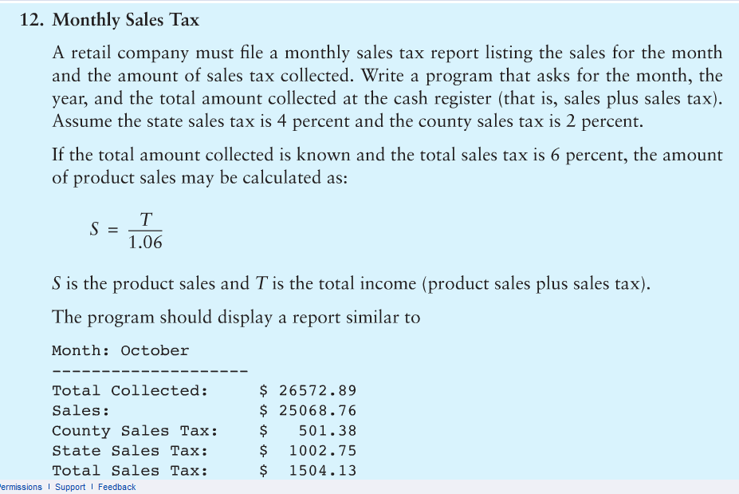

Checkpoints:
- Documentation
  - Name
  - Lab Number, name and purpose
  - Minimum of 4 other meaningful comments in the code (e.g. //Statements is NOT meaningful)
  - Self-documenting variable names
- Rate of state sales tax is to be a preprocessor directive (this means the identifier must be all UPPERCASE. Set it to 5%.
- Rate of county sales tax is to be a memory constant declared local to main(). Set it to 1.5%.
- Test data: September, 2014 and total collected of 71998.67
- Output is to contain your name printed using cout object
- Output is to be copied and pasted as a comment below the source code.
- Decimal points must be lined up beautifully as shown above.

